Cyngor Cymuned
Llanarmon yn Iâl

Community Council
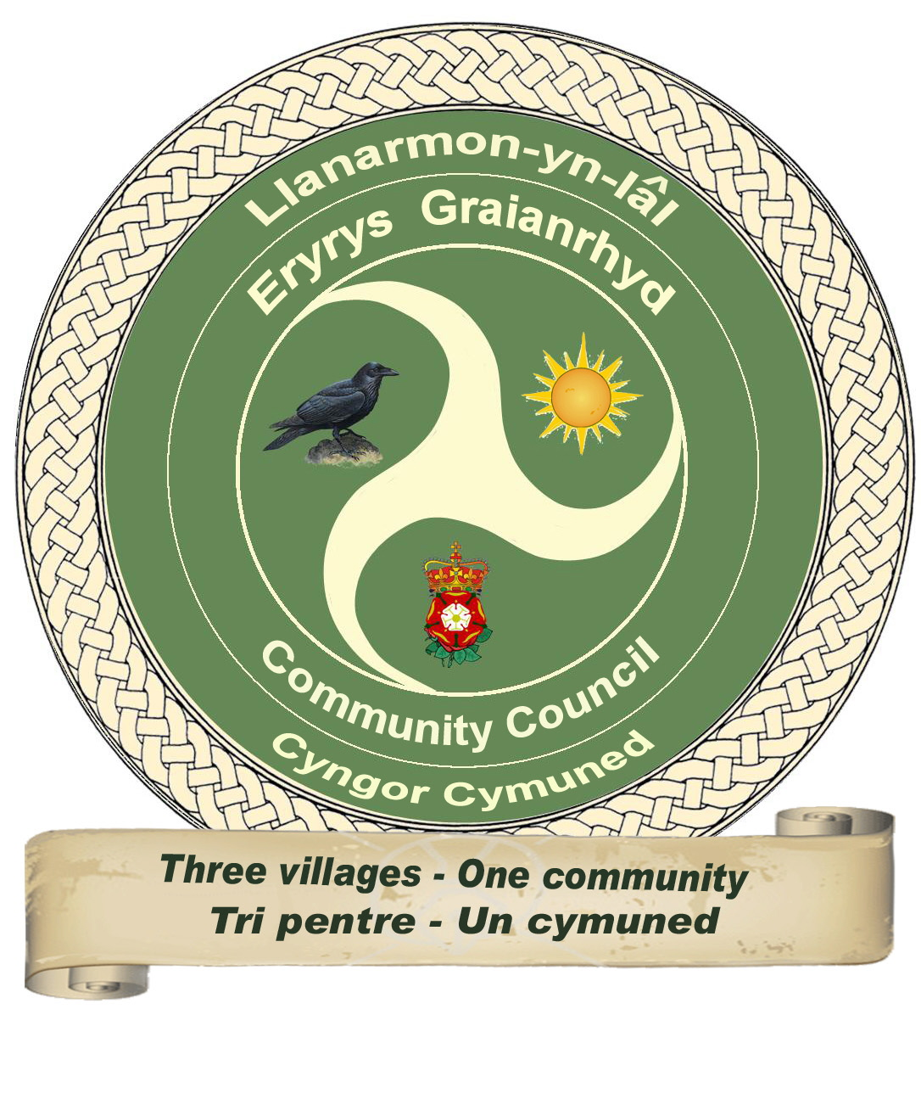
Bryn Llyn, Black Mountain
Treuddyn, Mold
Flintshire. CH7 4BW
Tel:: 01824 780358
norma_helen_wright@yahoo.co.uk

APPLICATION FOR PERMISSION TO
ERECT A MEMORIAL AND/OR INSCRIPTION

I/WE HEREBY MAKE AN APPLICATION FOR PERMISSION TO:-

ERECT A SINGLE MEMORIAL
PLACE A VASE
ERECT TEMPORARY WOODEN CROSS
ADD AN INSCRIPTION
NO KERB STONES ARE ALLOWED
(Delete as necessary)

IN ACCORDANCE WITH DETAILS GIVEN BELOW:

CEMETERY:
ST GARMON, LLANARMON YN IAL
DEWI SANT, ERYRYS
MAES Y DROELL, GRAIANRHYD
(Delete as necessary)
POSITION OF GRAVE SPACE: ...........................................................................................................................
NAME OF PERSON/S INTERRED: ...........................................................................................................................
..............................................................................................................................................................
MEMORIAL

FULL DESCRIPTION & MATERIAL USED
IN EVERY DETAIL AS FOLLOWS:

DIMENSIONS:

WIDTH: ............................. HEIGHT ABOVE GROUND: ............................. THICKNESS: ...................................

INSCRIPTION: .......................................................................................................................................................
...............................................................................................................................................................................................
.............................................................................................................................................................................................................................................................................................................................................................................................
NAME OF APPLICANT IN FULL: ...........................................................................................................................
ADDRESS AND EMAIL OF APPLICANT IN FULL: ...........................................................................................................................
...............................................................................................................................................................................................
...............................................................................................................................................................................................
SIGNATURE OF APPLICANT IN FULL: ..........................................................................................................................

Should the holder of the exclusive rights be interred in the grave, the above applicant will need to provide one of the following:
a) a letter to prove they are the only surviving son/daughter
b) if they have brothers/sisters, a letter will be required from each of them giving the applicant permission to continue

No permit will be granted unless the above is adhered to

MONUMENTAL MASON

NAME: ..........................................................................................................................................................
ADDRESS:...................................................................................................................................................................................................................................................................................................................................................................................................................................................................................................
Code of Working Practice (To meet BS 8415):………………………………………………………………..
.......................................................................................................................................................................
Ground Anchor System:........................................................................................................................................
.......................................................................................................................................................................
BRAMM/NAMM registration number:………………………………………………………………

Cemeteries Office contact number – 01824 780358
Please return to Mrs Norma Wright Clerk, Bryn Llyn Black Mountain Treuddyn MOLD Flintshire CH74BW
Cheques to be made payable to Llanarmon yn Ial Community Council.

All monuments and other memorials of whatever description admitted into the cemeteries shall remain the sole responsibility of the owner thereof. The Council shall not be held responsible for any damage, loss or breakage which may occur, however caused.

No memorials are to be fitted prior to a permit being issued.
N.B. Spot checks will be made on memorials.

